**Base Class Theology**

This is a new approach to theology in the likes of comparative religion which is based on principles of object-oriented computer programming. OOP is a way of thinking about software development where complicated systems are broken down into smaller, more manageable objects.

Base class theology views the universe as a single object, as you have heard in various religions which strive to conceptualize it. In this sense, the religion class extends from the parent class, universe (or nature). Just as a class in OOP can be used to define the properties and behaviors of all objects of a certain kind, religion can also be used to define the properties and behaviors of the universe. Then, comparing, and contrasting religion classes, can illuminate a way to abstract ancient and timeless properties of the universe as a base class of them. This is an alternative method to observation of the real world absent of any period knowledge of religion, in which we use the efforts of many prophets to come to the truth by inner joining them or truths.

The focus here is not to strip away the utility of religion for atheistic science, but to understand the truth of religions in terms of HOW *people* universallyextend religion from the universe/nature to reveal clear true theological method with scientific and rational and precision. Or as Tesla said, “It might as well be said that God has properties. He has not, but only attributes and these are of our own making.”.

Nikola Tesla was a famous inventor and engineer who was known to be Pantheist. Pantheism is the declaration that the universe of matter and energy IS the consciousness people *call* God. He believed the universe was all a single conscious system, and brought forth many great insights over his lifetime because of his attunement to the principle. He wrote:

"The Buddhist has no fear of death because he believes in reincarnation. The Christian has no fear of death because he believes in Heaven. But I believe in neither reincarnation nor Heaven, yet I have no fear of death. Why? Because I do not believe in a personal God, but in a great, impersonal, universal Mind. This Mind is in everything, and everything is in it. I am a part of it, and it is a part of me. When I die, my individuality will cease to exist, but the Mind will go on. I am one with the Mind, and the Mind is one with me."

The property of the conscious universe he extrapolated from religions extending from the base class led him to a universal property of the base class nature, which we call the conscious universe. Then the dynamics of it through empirical observation and experimentation. Then, his place in that universe became his belief (or knowledge). He had the view of a “great, impersonal, universal mind.”.

To reiterate: nature is the physical world around us upon which all religions are based. Base class theology views theology as a way of understanding nature where the human method is universal. It sees religion as a way of categorizing thought and actions according to the results they produce for society, people, and the environment. People did this across time and cultures to try to understand what was “good” or “bad” in terms of how to control/organize themselves as a group/culture.

For example, base class theology might categorize a religious belief as Positive if it leads to actions that are good for society and the environment. It might categorize a religious belief as Negative if it leads to actions that are harmful to society and the environment.

Base class theology can be used define good and bad as actions that lead to Positive or Negative outcomes for the whole system. However, not for the matter of hard coded laws, but a dynamic in the given context. It is a process, not a product. For example, if sin can be seen as anything that harms or causes pain, love can be seen as a manifestation of the force that Sustains life.

From the perspective of base class theology, good and bad are not absolute. They are determined by the context and the impact of actions on the immediate or total system.

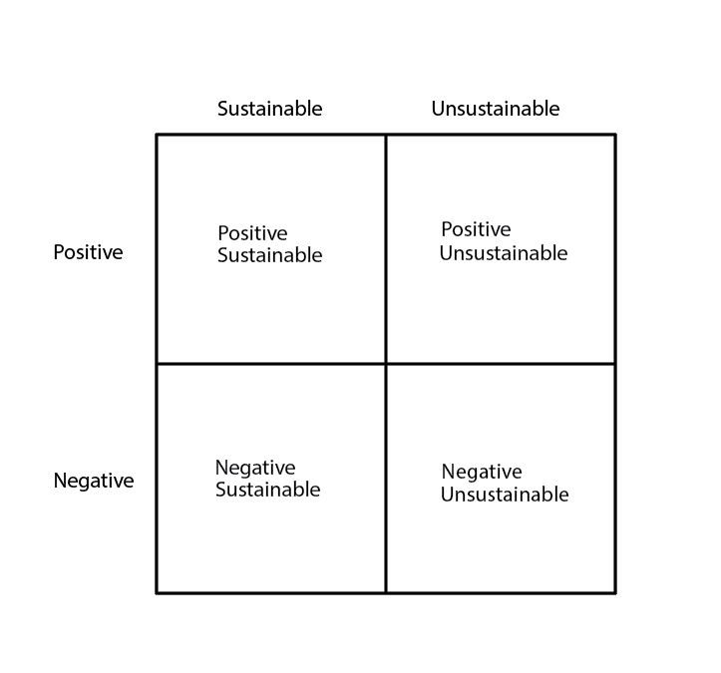

If you sin against, that is to say you have acted in a way which Negatively and Unsustainably harms some other form in a way that only destroys. If you love to, it is to say that you have acted towards someone or something which is Positive and Sustainably reinforces the existence of that thing. There is gray area. Say you tell someone a truth they needed to hear to Sustain, but did it in a rude way. That may be Negative but overall, more Sustaining for that subject. It could be viewed as ‘tough-love’ You could also tell a sugar-coated lie which could be viewed as Positive but Unsustainable for that subject.

The concept of Mara in Buddhism may be a good example of Negative and Unsustainability.

In Hinduism, of the Dancing Shiva, Positive Sustainability could be the drum in hand, the Negative Unsustainable force being the fire in the other. The little ignorant man may represent those how exist Positively in an Unsustainable fashion, as a slave would and was represented by it in the caste system.

In Abrahamic religions, Jesus, or the embodiment of love, may be a good personification of Positive and Sustainable. The ten commandments may be warnings about what is Negative an Unsustainable, where the part about it being the only correct way to think, an error.

In Judaism for example, the “burning bush” could be seen as a fractal taxonomic tree of life, as all life extends from biologic functions which are Positive and Sustainable, which has the eternal force of entropy (the burning Negative Unsustainable) pushing back on it.

Yin Yang? Positive Sustainable, the white tear-drop, Negative Unsustainable, the black tear-drop. Positive Unsustainable, the white circle in the black-teardrop, and Negative Sustainable, the black circle in the White-teardrop.

Since we are describing nature, suppose the shift from Positive Unsustainable to Negative Unsustainable to be Fall. From Negative Unsustainable to Negative Sustainable to be Winter. From Negative Sustainable to Positive Sustainable to be spring. And from Positive Sustainable to Positive Unsustainable to be spring. This is the object relation analysis of the seasons of life in the context of climate.

You may find or realize many other examples of this and even better examples using the ones I have pointed out. This method of categorization applies to everything from weather systems, to life systems, to electrical engineering circuits.

The utility of religion in general is the power of personifying systems so they can be considered in terms of the self. The utility of doing this through the self as a means of entity, is for the personalization and relatability of that religion or belief structure for the efficiency in handling one’s own default mode network. By personifying these principles, base class theology can help people to understand them more easily and to see how they relate to their own lives.

AFTERLIFE

There are several times in life that the brain releases DMT, which is the most powerful psychedelic on Earth. When you die is one of them, if your chemical-electrical and enzyme spectrum in the moment support it. While objectively it may be true that there is no soul or mind without the body, but also that subjectively, a being could stretch its lifetime infinitely to itself given Positive and Sustainable conditions for it.

APPEAL TO ATHEISTS

Huxley said something like; wise men wrap their words around the world, not the world around the words. Atheism is so often reactionary to religions such as with Abrahamic ones, but declaring there is no God is just a much a statement of faith as saying there is one. This is the success of Pantheism, that it has defined “God” as something which exists. Look around. That is the universe observing itself; conscious universe. Decompartmentalizing yourself from it in this manner is an advantage on te spectrum of open-mindedness.

CONCLUSION

Base class theology is a new and innovative approach to theology. It is based on the principles of object-oriented programming. Base class theology has the potential to unite people of different belief systems, and to help people to better understand the world around them. It acts as a root node between cultures, and ways of thinking once someone has reached a multi-paradigmatic view demanded by comparative religion where many religions contain overlap and differences. It is a description of the process for their invention, which itself can be used to tell good from bad with more flexibility to context. A Base Class Theologian dwells not on individual religions, but this universal present and flexible sense.